Acute Stress Disorder Symptoms Misconceptions in Traumatizing Events Survivors and PTSD
Part two: Methodology
Student's Name
Institution Affiliation
Date

Methodology
Project description
The project will use a descriptive research design to assess the number of traumatizing event survivors who don't receive Acute Stress Disorder due to misconceptions about some symptoms of ASD. The purpose of the study is to describe the nature of the demographics of the traumatized event survivors who do not receive immediate intervention. The research will use qualitative research methods of data collection such as surveys and observation to identify the statistical nature of the problem. The research study will be carried out in Chicago and Texas, and the participants will be people who experienced traumatized events within five years. Data will also be collected in hospitals on post-traumatic stress disorder (PTSD) patients. Other people in the streets will also be participants, and they will be used to identify their knowledge on ASD, symptoms, and treatment. The participants who experienced traumatizing events will help to describe the nature of the treatment and the duration they received the medication. While the medical records in the hospitals will be used to identify the time the patients experienced traumatizing events and the period they were treated. Descriptive analysis of the collected data will be used to identify extend of the problem among the American population through the grouping of data. Data will be presented in tables, graphs, and charts. The conclusion will be made about the state.
A descriptive study design will be effective in the research study because it will help describe the problem of many misconceptions of ASD symptoms that make many traumatizing events survivors not be immediately taken to hospital. Its data collection methods are efficient in collecting people's opinions or perceptions, such as a questionnaire. The use of the statistical data on the period of treatment of survivors of the traumatizing events. Actual data will be collected in the shortest time possible to identify study results. However, the descriptive study design has some drawbacks, such as the reflection of bias from the statistical interpretation. The descriptive problem might not reflect the whole population, and there is a possibility of wrong information from the participants. The drawbacks will be dealt with by using the statistical data from the hospitals, which will help reflect the problem. Questionnaires will be designed to help the participant provide relevant information to reduce unwanted answers. Targeted participants will be from the major traumatizing events that can be easily be verified.
Research question
Are there some survivors of the traumatizing event with ASD who are not treated despite various available treatments? The research study aims to identify some of the traumatizing events not taken to the hospital or for help before the condition changes to PTSD. The ASD symptoms are usually identified early; thus, lack of early treatment leads to the development of PTSD (Bryant and Panasetis, 2001).
Hypothesis
Traumatizing events survivors with ASD are not immediately treated due to insufficient information about Acute Stress Disorder and misconceptions about ASD symptoms. To test this hypothesis, data will be collected through questionnaires, identifying their knowledge about ASD and misconceptions about the disorder. While those who had the disorder will help by describing why they were treated late or early. Suppose 60% of the participants illustrate they do not have efficient knowledge and think some of the misconception of ASD symptoms are true, such as nightmares of the traumatizing event. In that case, survivors result from fear or might disappear after a while. The hypothesis will be positive because more than half of the participants would have seconded the hypothesis. While statistical data from the hospitals illustrating the time traumatizing event survivors were treated with ASD or PTSD and the reasons recorded in the hospital admission forms on the persistence of the symptoms before they were taken for the medication (Winston et al., 2002). It will help to test the alternative hypothesis of (some of the traumatizing event survivors are taken for treatment late due to misconception of ASD symptoms) It will be used to test the alternative hypothesis by illustrating the reasons for the late treatment of traumatizing event survivors.
Sample and participants
The study location will be in Texas and Chicago, and two locations were chosen to help to provide a wide description of the study. The results from the two locations will be used to present other cities. The participants will be the people who experienced traumatized events and will be located through schools, colleges, and religious centers. They will be useful in the study because they will help provide information on whether they were treated early for ASD or after turning into post-traumatic stress disorder. People within the society will also be used as participants to identify their knowledge about ASD symptoms and perception. They will also help to describe extend of the problem within the society. Statistical data from the hospitals that will cooperate to share their data based on the number of people treated with ASD and PTSD and time for treatment for comparative analysis.
Sampling procedures
Various types of sampling will be used in the research study because it involves collecting the qualitative and quantitative data used for analysis. All the hospitals willing to provide their data on the number of patients treated with ASD and PTSD will be included in the study. The study targets more than 200 medical facilities' contributions in both cities. The convenience sampling method will sample survivors of traumatized events in community institutions such as schools and religious centers. Participants willing to participate and who experienced traumatizing events will be selected. However, the selection will be limited to the first 500 people in every city. This sampling method is advantageous because the participants are volunteers, and it is easy to get them. While simple random sampling method will be used to select participants in the areas of the study to identify the general knowledge of ASD. Five people will be randomly chosen in every area of Chicago and Texas. The random sampling method will be used because it is easy to identify participants while those not interested can be easily replaced.
The selection method will depend on age, gender, and ethnic background. The participants will be of the age of 12 and above who can answer questions effectively. The participants. Guardians or the parents of the children will help answer the questions. The gender quality will be observed by selecting equal men and women. While the ethical background will be observed when selecting an equal number of the majority ethical groups, while minority ethical groups will be presented by two individuals depending on the area. The study aims to cover 50% of Chicago and Texas City.
Data collection procedures
Data will be collected through descriptive quantitative research methods, using the survey and statistical data from the hospitals. It will also capture qualitative data collection methods such as the use of questionnaires. The research survey aims to collect first-hand data from the participants, such as the use of questionnaires. Questionnaires will be distributed to all participants to answer the questions quickly. The use of the survey in data collection will be beneficial because it aims it helps to identify the real representation of the problem on the ground without changing its nature. It also helps to capture qualitative data on the people's perception of ASD symptoms about early treatment. However, it has some drawbacks, such as bias from the participant's response or selection process. The problem will be solved by providing the guidelines on selecting participants, and questionnaires will guide the participants to provide appropriate answers. Statistical data from the hospitals will be collected systematically and analyzed. Systematic collection of the data from the hospitals about ASD patients will help reduce confusion during the data analysis.
Instrumentation and tools
The main instrument used in the research study is the hospital forms that record the patient's information and treatment period. The forms will be used to identify statistical data of the number of ASD patients and the treatment time. It is an important data collection instrument because it makes it easy for the researchers to collect data that it would have been difficult for the doctor or patient to answer. If the forms can be crosschecked with the hard copies for authenticity. A questionnaire is another tool for data collection that will be used. Questionnaires might have some bias or other errors that lead to incorrect answers. To avoid such problems, questionnaires will be made by the professionals from the University of Chicago in the research department. All ethical considerations for the research will be considered during questionnaire formulation, and the objectives of the study will also be considered.

Appendix
The forms will be used are used to fill the patients information while on Physiological hospital treatment. Collection of these forms for ASD and PTSD of the hospitals for the last three years will be used in the study.
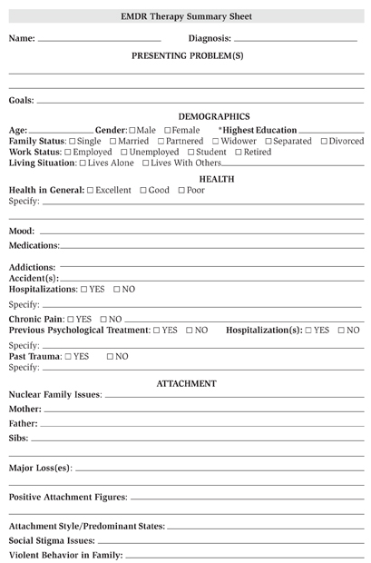

2. Questionnaire sheet
The questions below are for the research study and should be answered with honestly. Discretion of the information provided will be highly regarded. Choose, 0 means does not know, 1, (have an idea but does not understand) 2. (Conversant)
- How old are you ………..
- Have you ever Traumatizing event , 0 1 2
- Have you ever experienced Acute Stress Disorder, 0 1 2
- Can you identify any ASD Symptoms, 0 1 2
- What was the symptoms …..
- Were you taken to the hospital immediately 0 1 2

References
Bryant, R. A., & Panasetis, P. (2001). Panic symptoms during trauma and acute stress disorder. Behaviour Research and Therapy, 39(8), 961-966.
Winston, F. K., Kassam-Adams, N., Vivarelli-O'Neill, C., Ford, J., Newman, E., Baxt, C., ... & Cnaan, A. (2002). Acute stress disorder symptoms in children and their parents after pediatric traffic injury. Pediatrics, 109(6), e90-e90.

